# Explain the following Concepts in DBMS: (8)

* 1. Transactions in Database
  2. Indexing
  3. Query Stored procedures
  4. SQL Injection

# Differentiate the following Terms (8)

* 1. Active Attack VS Passive Attack
  2. Commit VS Roll Back
  3. Database Sharding VS Distributed Database
  4. 1st Normal Form VS 5th Normal Form

1. **Integrity Rules. (6)**

**Write all constraints which are not being followed in the below table:-**

|  |  |  |  |  |  |
| --- | --- | --- | --- | --- | --- |
| **RollNo** | **Name** | **DOB** | **Gender** | **CNIC** | **12th Marks** |
| **1** | **Harsh Agarwal** | **05/13/2001** | **M** | **3650151934788** | **854** |
| **2** | **Stuti Mishra** | **05/07/2003** | **Female** | **3650191764825** | **935** |
| **2** | **Yesh Dubey** | **01/12/2005** | **M** | **3650116347964** | **1250** |
| **3** |  | **08/11/2003** | **M** | **36501519347881** | **635** |
| **4** | **Mishra** | **06/10/2001** | **M** | **3650161791435** | **976** |

# Create an ER Diagram about University with minimum 5 tables. (10)

# Normalize the given table up to maximum possible normal form. [8]

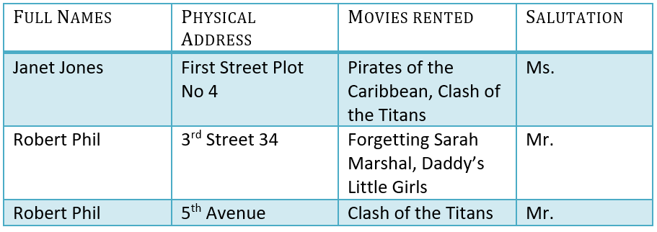

# Write SQL Queries according to the given table: - (10)

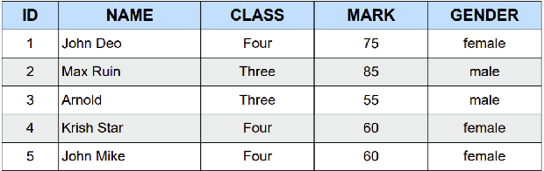

* 1. Create the upper table with datatypes, Primary Key, Characters, etc.
  2. Insert the upper given data records in the table.
  3. Update the 3rd Records name from “Arnold” to “Usman”.
  4. Delete the 5th Row Completely.
  5. Display the students record with the highest marks.